Project Plan

Traffic Penalty Management Software

Thi Ngoc Nhu Nguyen – s5325919

James Odike – s5331003

Table of Contents

1.0 Introduction 3

1.1 Problem Background 3

1.2 Scope 3

1.3 Document contents 3

2.0 Work Breakdown Structure 4

3.0 Activity Definition & Estimation 5

4.0 Gantt Chart 6

# Introduction

## Background

## Scope

## Document contents

*Include some background information about the problem, the scope and what this document will contain.*

# Work Breakdown Structure

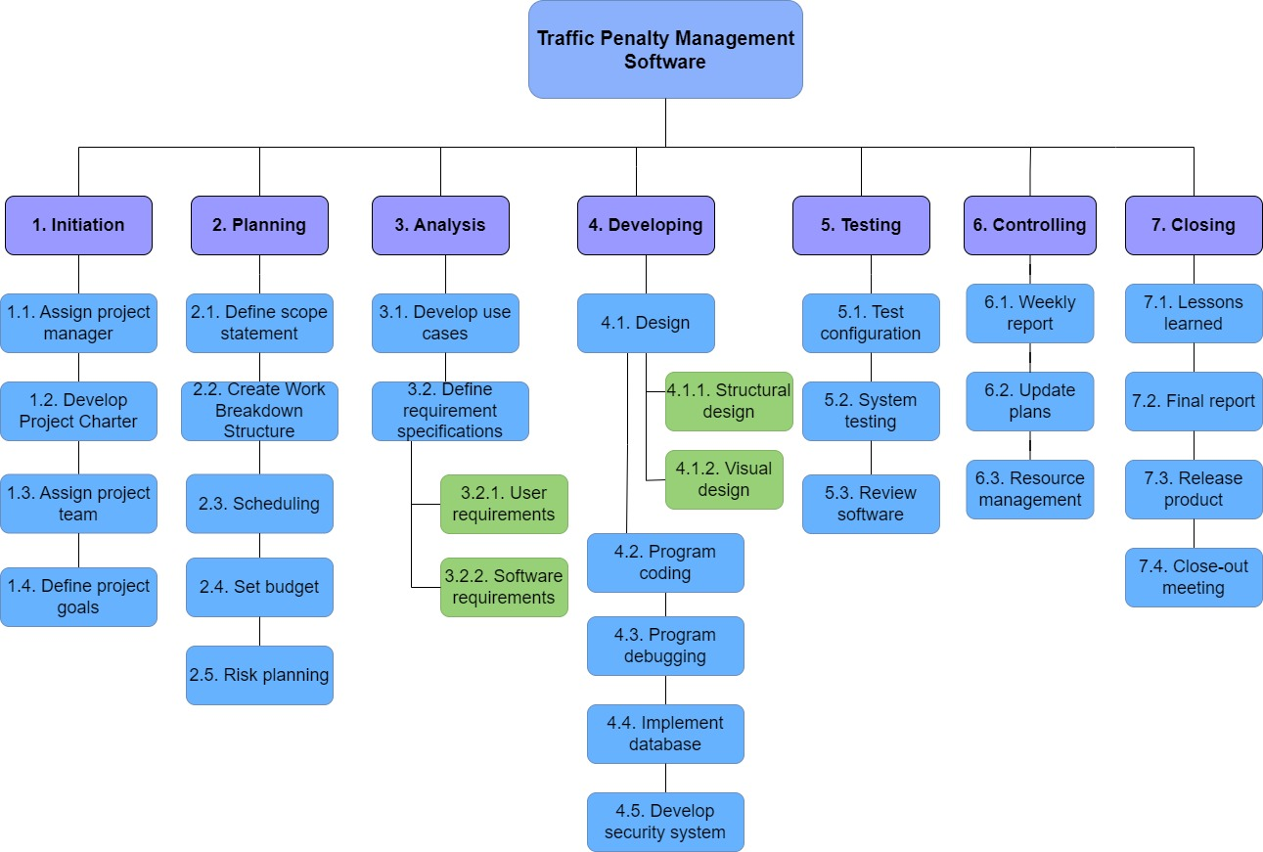

# Activity Definition & Estimation

**3.1 Initiation**  
The initiation stage is where the groundwork is laid to set the project in motion. This phase comprises four key activities that collectively establish a strong framework for the project's execution:

3.1.1 Develop Project Charter: The project charter serves as the project's formal initiation document. It outlines the project's high-level scope, objectives, stakeholders, and initial constraints. In this activity, project sponsors, stakeholders, and the project management team collaborate to draft and approve the project charter. This document provides the project manager with the authority and direction needed to proceed.

3.1.2 Assign Project Manager: Selecting an experienced and capable project manager is critical for project success. In this activity, a project manager is chosen based on their expertise, leadership skills, and ability to drive the project forward. The project manager becomes the central point of contact for all project-related matters and assumes responsibility for planning, execution, and monitoring.

3.1.3 Assign Project Teams: Identifying and assembling the right project teams is essential for achieving project goals. This activity involves forming cross-functional teams with members possessing the necessary skills and expertise. Team members are selected based on their ability to contribute to different project aspects, ensuring a diverse skill set and comprehensive coverage of required tasks.

3.1.4 Define Project Goals: Clearly defining the project's goals and objectives is paramount. During this activity, project stakeholders collaborate to articulate specific, measurable, achievable, relevant, and time-bound (SMART) goals. The defined goals provide a clear direction for the project, guiding decision-making and resource allocation throughout its lifecycle.

* 1. **Project**

The project stage focuses on the detailed planning and setup required to initiate and execute the project. The key activities in this stage are "Scope Statement," "Work Breakdown Structure (WBS)," "Scheduling," "Time Estimation," and "Budget."

3.2.1: Scope Statement Objective: Define and document the project's scope, objectives, deliverables, and boundaries. The tasks during this stage include:

* Project Objectives: Clearly outline the goals and objectives the project aims to achieve.
* Scope Definition: Define the boundaries of the project, specifying what is included and excluded from the scope.
* Deliverables: Identify and describe the tangible and intangible outcomes the project will produce.
* Constraints and Assumptions: Document any limitations, assumptions, and constraints that may impact the project's scope and execution.

On completion of this phase, our objective is to provide a project scope statement document detailing objectives, scope boundaries, deliverables, and constraints.

3.2.2: Work Breakdown Structure (WBS) Objective: Break down the project's scope into manageable work packages, tasks, and sub-tasks. The tasks during this activity include:

* Decomposition: Break down the project's scope into smaller, manageable components using a hierarchical structure.
* Task Identification: Identify specific tasks and activities required to complete each work package.
* Dependencies: Define logical relationships and dependencies between tasks to establish the project's sequence.
* WBS Documentation: Create a visual representation of the WBS, illustrating the project's hierarchical breakdown.

On completion of this phase, our objective is to develop a Work Breakdown Structure diagram depicting project components, tasks, and dependencies.

3.2.3: Scheduling Objective: Create a detailed project schedule that outlines the sequence, duration, and dependencies of project tasks. The tasks during this activity include:

* Task Sequencing: Arrange tasks in a logical order to ensure smooth project flow.
* Task Duration Estimation: Estimate the time required to complete each task based on historical data, expert judgment, and other relevant factors.
* Critical Path Analysis: Identify the critical path – the sequence of tasks that determines the shortest project duration.
* Schedule Visualization: Develop a Gantt chart or timeline to visually represent the project schedule.

On completion of this phase, our objective is to develop a Project schedule with task sequence, start and end dates, and critical path highlighted.

3.2.4: Time Estimation and Budget Objective: Estimate the time required for each task and allocate resources to develop a project budget. The tasks during this activity include:

* **Time Estimation:** Calculate the total project duration by summing up the estimated durations of individual tasks.
* Resource Allocation: Assign appropriate resources (human, equipment, materials) to each task based on expertise and availability.
* **Cost Estimation:** Estimate the costs associated with each task, including labour, materials, equipment, and any other relevant expenses.
* **Budget Preparation:** Develop a comprehensive project budget by aggregating the estimated costs.

3.2.5: Risk planning: In this activity initiation stage, the focus is solely on risk planning, allowing the project team to establish a comprehensive risk management framework. By proactively addressing potential issues and uncertainties, the project sets the stage for effective decision-making, resource allocation, and overall project success.Top of Form

* 1. **Analysis**

In this stage of the project management lifecycle, we are focusing on understanding and defining all parts of the project requirements. Our goal is to ensure that stakeholders have a clear understanding of what is the aim of the project and its achievements.

This stage consists of four key activities:

* + 1. **Use cases:** In this stage, scenarios that illustrate step-by-step interactions between users and project deliverables are created. This stage helps to validate the project requirements, discover potential issues, and ensure the project addresses real-world usage scenarios.
    2. **Requirement Specifications:** In this activity, we gather and document the project requirements according to milestones and high-level requirements. The project managers collaborate with the stakeholders to develop the goals, constraints, and desired outcomes of the project.
    3. **User Requirements:** In this activity, a thorough understanding of the needs, preferences and expectations of end users are studied to help refine the project’s direction and ensure user needs are at the forefront of all decision-making.
    4. **Software Requirements:** This activity involves the defining of the functional and non-functional requirements of the software. Developers and project teams work closely together to specify features, functionalities, performance, and technical constraints. This is a crucial stage because it provides the blueprint for development and serves as the foundation for design and coding.
  1. **Developing**

During the developing stage, the project transitions from the planning phase to the execution phase. This stage involves transforming the conceptual plans into tangible deliverables through a series of structured activities. The stage comprises four key activities, including design, coding, and implementation:

3.4.1. **Structural Design:** In this activity, the project team creates a detailed structural design that outlines the overall architecture and layout of the project. This includes defining the system's components, modules, and their relationships. The structural design serves as the blueprint for the technical implementation and ensures a solid foundation for subsequent stages.

3.4.2. **Visual Design:** Visual design focuses on the user interface and user experience (UI/UX) aspects of the project. Designers collaborate to create visually appealing and intuitive user interfaces that align with the project's goals and target audience. The visual design substage involves crafting the graphical elements, layout, typography, and overall aesthetics of the project's user interface.

3.4.3. **Program Coding and Debugging:** In this activity, developers translate the design specifications into actual code. They write, test, and refine the program code according to established coding standards and best practices. As the code is developed, thorough testing and debugging are carried out to identify and rectify any errors, ensuring that the software functions as intended.

3.4.4. **Implement Database and Develop Security System:** This activity involves setting up and implementing the project's database architecture. Database administrators and developers work together to design, create, and populate the database with relevant data. Simultaneously, a security system is developed to safeguard the project against potential threats and vulnerabilities. This includes implementing access controls, encryption, authentication mechanisms, and other security measures.

During these activities, collaboration between design, development, and database teams is crucial. Effective communication ensures that the project remains aligned with the established specifications and goals. By meticulously crafting the structural and visual aspects of the project, writing robust code, and implementing a secure database and security system, the developing stage sets the project on the path toward successful execution and eventual delivery of the desired project outcomes.

* 1. **Testing**

In the developing stage, the project gains concrete form as it undergoes rigorous testing and evaluation. This stage comprises three pivotal activities:

3.5.1. **Test Configuration:** Project teams configure the testing environment, setting up the necessary tools, frameworks, and resources for comprehensive testing. This ensures a controlled and consistent environment in which to assess the project's functionality, performance, and reliability.

3.5.2. **System Testing:** Rigorous system testing is conducted to evaluate the project's overall functionality and integration. This involves subjecting the software to various scenarios, inputs, and conditions to identify and rectify any defects or discrepancies. The goal is to ensure that the project meets the defined requirements and performs reliably under different conditions.

3.5.3. **Review Software:** A critical review of the software is carried out to assess its alignment with the project's objectives and specifications. Project stakeholders, including team members and clients, evaluate the software's features, user experience, and overall quality. This review process helps identify any gaps or areas for improvement before proceeding to the next stages.

Through these activities, the developing stage emphasizes thorough testing and evaluation, essential for identifying and addressing potential issues. By rigorously configuring the testing environment, conducting comprehensive system testing, and subjecting the software to critical review, the project advances toward its final stages with increased confidence in its functionality and adherence to requirements.

* 1. **Controlling**

The controlling stage of project management is dedicated to actively overseeing project progress, ensuring alignment with goals, and optimizing resource utilization. This stage comprises three vital activities:

1. Weekly Report: Regular weekly reports are generated to provide a picture of the project status, including accomplishments, challenges, and key performance indicators. These reports offer stakeholders a comprehensive view of progress and facilitate informed decision-making by highlighting achievements and potential deviations from the project plan.

2. Status Updates: Continuous status updates are communicated to stakeholders, keeping them informed about project developments and any emerging issues. Timely updates enable proactive responses to challenges and ensure that all parties remain aligned regarding project objectives and milestones.

3. Resource Management: Resource allocation and utilization are closely managed to maximize efficiency and productivity. Project managers oversee the allocation of personnel, equipment, and finances, ensuring that resources are distributed effectively to support project tasks and goals.

Through these activities, the controlling stage enhances project visibility, enables informed decision-making, and maintains effective resource utilization. By consistently generating weekly reports, providing status updates, and managing resources strategically, the project maintains a strong trajectory toward successful execution and accomplishment of its intended outcomes.

* 1. **Closing**

The controlling stage in project management focuses on refining project processes, capturing valuable insights, and preparing for project closure. This stage encompasses three key activities:

1. **Lessons Learned:** A thorough assessment is conducted to identify successes, challenges, and areas for improvement throughout the project's lifecycle. Lessons learned are documented to extract valuable knowledge that can inform future projects and enhance organizational practices.

2. **Final Report:** The final report summarizes the project's entire journey, highlighting achievements, challenges, and outcomes. It provides stakeholders with a clear understanding of the project's execution, results, and adherence to initial objectives.

3. **Release Report and Close-Out Meeting:** During this activity a release report is developed outlining the final deliverables and confirming their readiness for deployment or implementation. A close-out meeting brings together project stakeholders to review project achievements, discuss lessons learned, and formally close the project. This meeting provides an opportunity to celebrate successes, acknowledge contributions, and officially conclude the project.

Through these activities, the controlling stage facilitates continuous improvement by capturing lessons learned, ensuring effective project closure through documentation and formal meetings, and paving the way for smoother execution of future endeavours.

# Gantt Chart

*This section should contain your Gantt chart. The items in the Gantt chart should match the activity definition from section 3. You should also submit your Gantt chart file separately.*